Make sure you've installed Vue dev-tools. Take a screenshot of the shopping cart app showing the dev tools running for any one of your apps.

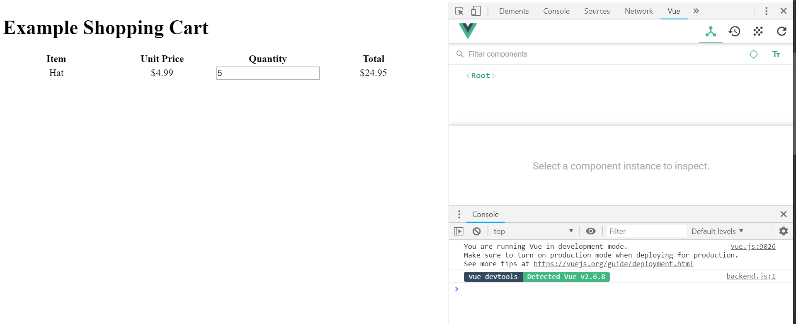

* Make a note of the Vue Debugging 101 section on pages 19-20.

